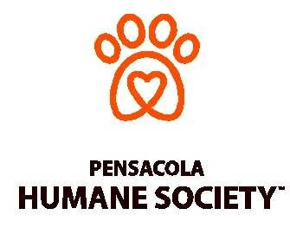
Barktoberfest 2017
Vendor Agreement Form

Company Name _________________________________________________________

Contact Person ________________________________________________________

Contact Email ___________________________________________________________

Address: _______________________________________________________________

City/State/Zip ___________________________________________________________

Phone _________________________________________________________________

Print Name _____________________________________________________________

Signature ______________________________________________________________

Date ___________

Will you be setting up an event table at Barktoberfest?
Will you need electric at the event?

Please check our map online at pensacolahumane.org/Barktoberfest and select your top three location choices? 1) ____ 2) ____ 3) ________

Full payment is due October 1… Please return form and a check payable to:
Pensacola Humane Society; 5 North Q Street; Pensacola, FL 32505
Phone: 850-898-3384 email: jeff@pensacolahumane.org

Your support for the animals at the Pensacola Humane Society is truly appreciated.

